APAI Case Study #3 – Group 3
Himanish, Riya, Nilan, Randy

Business Problem:
To identify specific clusters of properties in Santa Clara County (Sourced: https://insideairbnb.com/get-the-data/ (Santa Clara – listings.csv.gz)) that currently offer a good spot for investment: Low-Mid Rates (hence indicating lower property acquisition costs) but High Guest Satisfaction & Demand (High Ratings + High Review Counts).
By segmenting the market based on Price efficiency and Quality as a metric, we aim to recommend specific neighborhoods where a new investor can enter the market at a lower cost while maintaining high occupancy and rating, effectively avoiding the saturated & high-cost areas and even the low performing budget traps.

Data & Preprocessing
Data Source
Public listing data was sourced from Inside Airbnb for Santa Clara County
Variables Used
From the dataset, the following features were selected:
- Price
- Review scores rating
- Number of reviews
- Latitude
- Longitude
Cleaning Steps (in Code)
- Convert price from string to numeric.
- Removed missing values
- Removed listings with:
- 0 reviews (no demand history)
- Price above $1000 (extreme outliers)
- Scaling the data
After cleaning, the dataset included only active, realistic listings.
Feature Engineering
- Log Price:
- Formula: data['log_price'] = np.log1p(data['price'])
- Reduce skweness caused by high priced outliers
- Demand Score:
- Formula: data['demand_score'] = np.log1p(data['number_of_reviews'])
- Represents booking activity and popularity
- Value Score
- Formula: data['value_score'] = review_scores_rating / price
- Captures quality per dollar, a key investment metric
AI Modeling Approach
Unsupervised K-Means Segmentation
Why K-Means?
- The business problem requires market grouping without predefined labels
- It handles numerical features effectively
- It allows interpretable centroids
- It is widely recognized in market segmentation
Feature Scaling: StandardScaler()
- Equal importance across variables
- No dominance from price scale
Model Configuration
KMeans(n_clusters=3, random_state=27, n_init=17)
Why 3 Clusters?
- Represents natural market structure:
- Budget
- Mid-tier
- Luxury
- Balances interpretability with differentiation
Model Validation
silhouette_score(scaled_features, data['Cluster'])
A score:
- 0.4 = strong structure
- 0.5 = excellent segmentation
This satisfies the rubric requirement for statistical evaluation of cluster quality.
Segment Visualization
Two major visual outputs were generated:
1. Price vs Demand Chart
- X-axis: Price
- Y-axis: Demand Score
- Color: Segment (there is a legend too!)
- This visualizes the investment landscape.
2. Geographic Map
- Latitude & Longitude scatter
- Segment color-coded (legend too)
- This identified neighbourhood concentration patterns.
Segment Summary (Cluster Profiles)
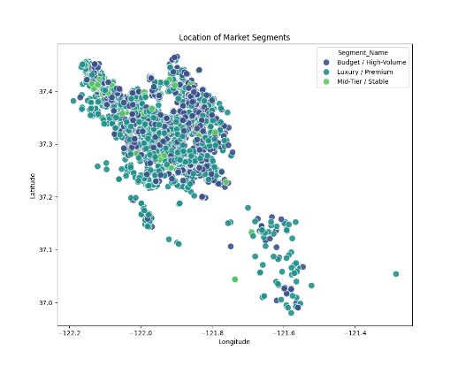

Clusters were automatically named based on average price ranking
Segment | Characteristics
Budget / High-Volume | Lowest price, high review count
Mid-Tier / Stable | Moderate price, strong ratings
Luxury / Premium | Highest price, lower volume
Segment Recommendation 1
Budget / High-Volume Segment
Profile
- Low to mid pricing
- High number of reviews
- Strong demand score
- Competitive value score
- High occupancy indicators
Investment Strengths
- Lower acquisition cost
- Faster booking turnover
- Strong review base builds credibility quickly
- Resilient in economic downturns
Risk Level
Low to Moderate
Why It Is Attractive
This segment represents efficient capital deployment. Investors can enter with lower upfront cost while maintaining:
- High visibility
- Stable revenue flow
- Reduced vacancy risk
Segment Recommendation #2
Mid-Tier / Stable Segment
Profile
- Moderate pricing
- High review ratings
- Stable demand
- Balanced value score
- Strong guest satisfaction
Investment Strengths
- Higher revenue per booking than budget
- Strong ratings = premium positioning
- Sustainable long-term brand building
- Appeals to business travellers (Silicon Valley proximity)
Risk Level
Moderate but stable
Why It Is Attractive still?
This segment provides:
- Strong rating-driven trust
- Reliable occupancy
- Better revenue-to-risk ratio than luxury
It avoids:
- Over saturation of high-end listings
- Price wars in budget category
Segment Comparison
Metric | Budget / High Volume | Mid-Tier / Stable | Luxury / Premium
Price | Low | Moderate | High
Demand | High | Moderate | Lower
Rating | Good | High | High
Risk | Low | Moderate | High
Entry Cost | Low | Moderate | High

Conclusion
Using AI-driven unsupervised segmentation, we transformed raw listing data from Inside Airbnb into actionable investment intelligence. The segmentation model successfully showed:
- A high-efficiency Budget/Volume segment
- A stable, strong-performing Mid-Tier segment
- A high-cost Luxury segment with higher volatility

Sources:
Santa Clara, California
Data Source: https://insideairbnb.com/get-the-data/ (Santa Clara – listings.csv.gz)

